BIG_DATA QUIZ Noyal Jonnalagadda

NXJ220008

Step 1

1. Review the data

Step 2

Step 3

Step 4

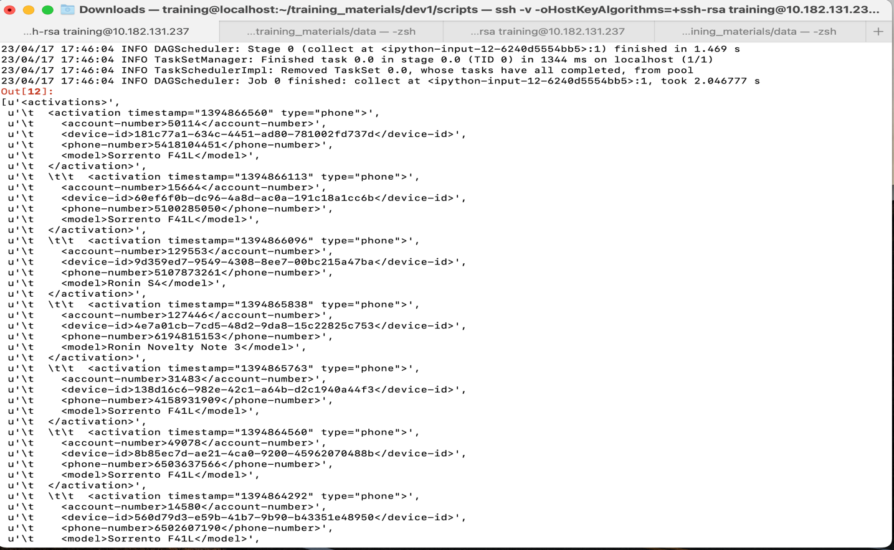

STEP 5

STEP 6

Step 7, 8

Step 9

Step 10

